Exercises: LAB 01

1. Write a program to store 10 marks in an array and show 1 st and 2nd highest marks on screen.

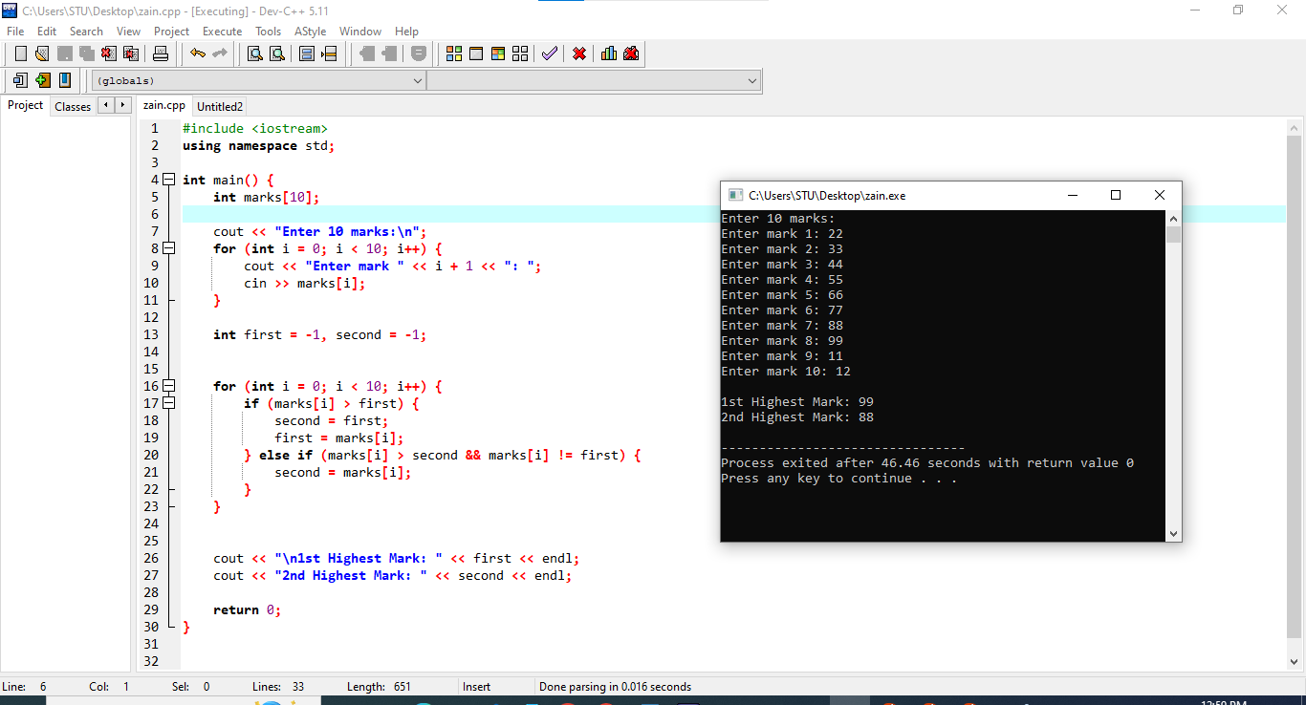

1. Write a program to take size of an array from user and store elements in an array. Take any element from user and search either entered number exist in an array or not using binary seach.

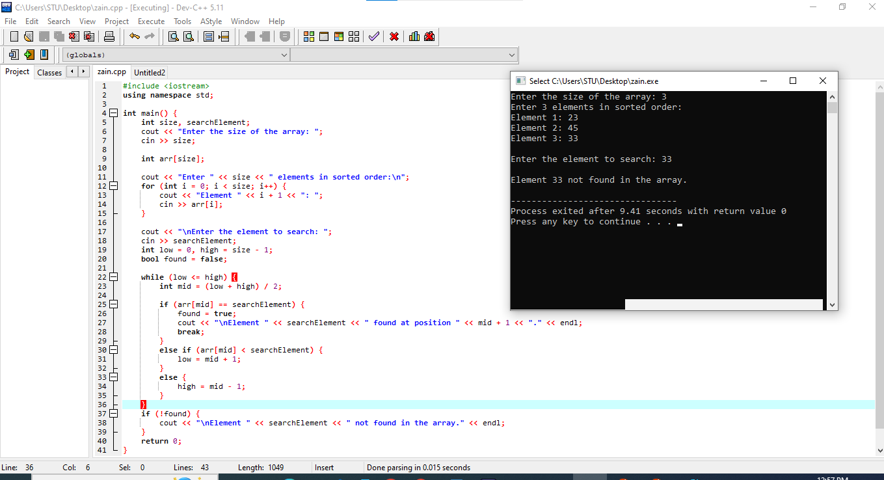

1. Write a program to take marks of 6 subjects of students and calculate the average of his/her marks and show grades according to his/her average. E.g if the average is more than 90 show A+, more than 80 show A, more than 70 show B, more than 60 show C, more than 50 shows D otherwise show F.

